1111111111111111111Practical No. 07

Aim: Write a program to find minimum cost spanning tree using Prim’s algorithm.
Software Requirements: Python IDE, Pycharm, Visual Studio Code, Jupyter Notebook
Theory:
Prim’s Algorithm is a greedy algorithm used to find the Minimum Cost Spanning Tree (MST) of a connected, weighted, and undirected graph. The MST is a subset of edges that connects all vertices with the minimum total edge weight and no cycles.
Working of Prim’s Algorithm
- Start from any vertex and mark it as visited.
- Select the smallest weight edge that connects a visited vertex to an unvisited vertex.
- Add the edge to MST and mark the new vertex as visited.
- Repeat steps 2 and 3 until all vertices are included in MST.
Example:
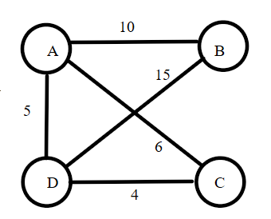
Step 1: Start from Vertex A
- Mark A as visited.
- Add edges (A-B, 10), (A-C, 6), (A-D, 5) to min heap.
- Pick the smallest edge → (A-D, 5). Add (A - D) to MST.

Step 2: Include Vertex D
- Mark D as visited.
- Add edges (D-C, 4), (D-B, 15) to min heap.
- Pick the smallest edge → (D-C, 4). Add (D - C) to MST.

Step 3: Include Vertex C
- Mark C as visited.
- Add edges (C-B, 15), (C-A, 6) to min heap.
- Pick the smallest edge → (A-C, 6). Add (A - C) to MST.

Step 4: Include Vertex B
- Mark B as visited.
- The only remaining edge that connects B is (A - B, 10).
- Pick the smallest edge → (A-B, 10). Add (A - B) to MST.

Final MST (Edges Chosen)
Edges included in the MST:
- (A - D, 5)
- (D - C, 4)
- (A - B, 10)
Total Minimum Cost = 5 + 4 + 10 = 19
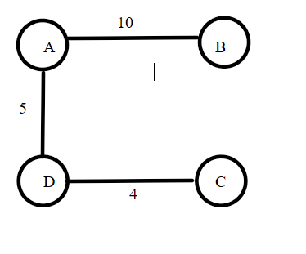

Program:
import heapq

def prim_mst(graph):
num_vertices = len(graph)
visited = [False] * num_vertices # Track visited nodes
min_heap = [(0, 0, -1)] # (weight, vertex, parent)
mst_cost = 0 # Total MST cost
mst_edges = [] # Store MST edges

while len(mst_edges) < num_vertices - 1:
weight, u, parent = heapq.heappop(min_heap) # Get minimum weight edge
if visited[u]:
continue # Skip if already included in MST

visited[u] = True # Mark as visited
mst_cost += weight # Add edge weight to total cost

if parent != -1: # Ignore the first picked node
mst_edges.append((parent, u, weight))

for v, w in enumerate(graph[u]): # Iterate over adjacent vertices
if w > 0 and not visited[v]: # If edge exists and v is unvisited
heapq.heappush(min_heap, (w, v, u)) # Store parent info

return mst_cost, mst_edges

# Taking user input for adjacency matrix
num_vertices = int(input("Enter number of vertices: "))
graph = []
print("Enter adjacency matrix (use 0 for no edge):")
for _ in range(num_vertices):
graph.append(list(map(int, input().split())))

# Compute MST using Prim's algorithm
min_cost, mst_edges = prim_mst(graph)

# Display Results
print("\nMinimum Cost Spanning Tree (MST) Edges:")
for u, v, w in mst_edges:
print(f"Edge ({u} - {v}) with weight {w}")

print("Total Minimum Cost of MST:", min_cost)

Input:
Enter number of vertices: 4
Enter adjacency matrix (use 0 for no edge):
0 10 6 5
10 0 0 15
6 0 0 4
5 15 4 0
Output:
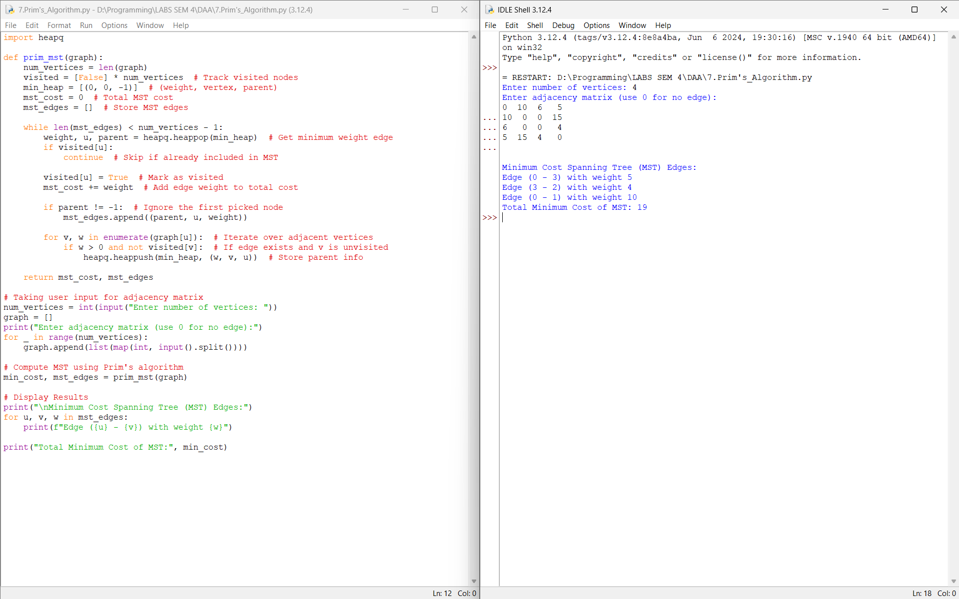
Conclusion:
Hence, I have executed the python program to find minimum cost spanning tree using Prim’s algorithm.

